Functional Requirements:

1. The system shall allow a customer to withdraw money from his/her banking accounts.
   1. The system shall display a user menu to the customer.

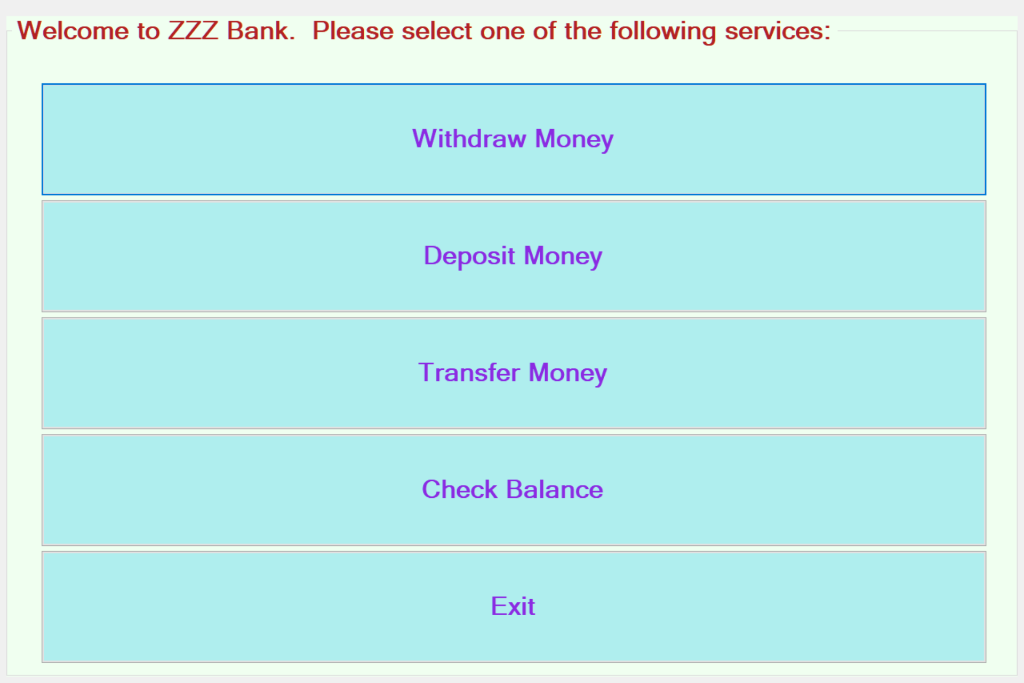

* 1. The customer shall select “Withdraw Money” in the menu.
  2. The system shall display a list of accounts of the customer to be selected for withdrawal.
     1. The system shall retrieve the account information from the central database system with the customer’s id.
     2. The system shall format and display only account numbers to the customer.

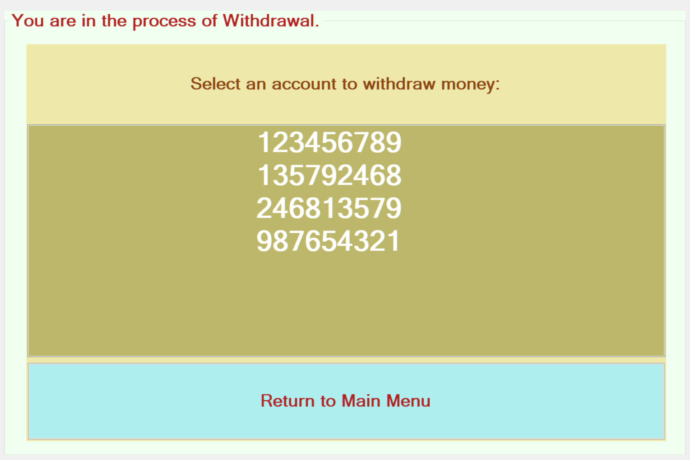

* 1. The customer shall select one account from the list for withdrawal.
  2. The system shall update the date of the daily transactions of the selected account.
     1. If the last date of the transactions is not today’s date, the system shall change the date of the transactions to today’s date and reset the daily transaction total to $0.
  3. The system shall check if the account’s daily transaction total have reached $3000 (see NR1).
     1. If the total has reached $3000 already, the system shall display an error message to the customer, and return to Step 1.3.

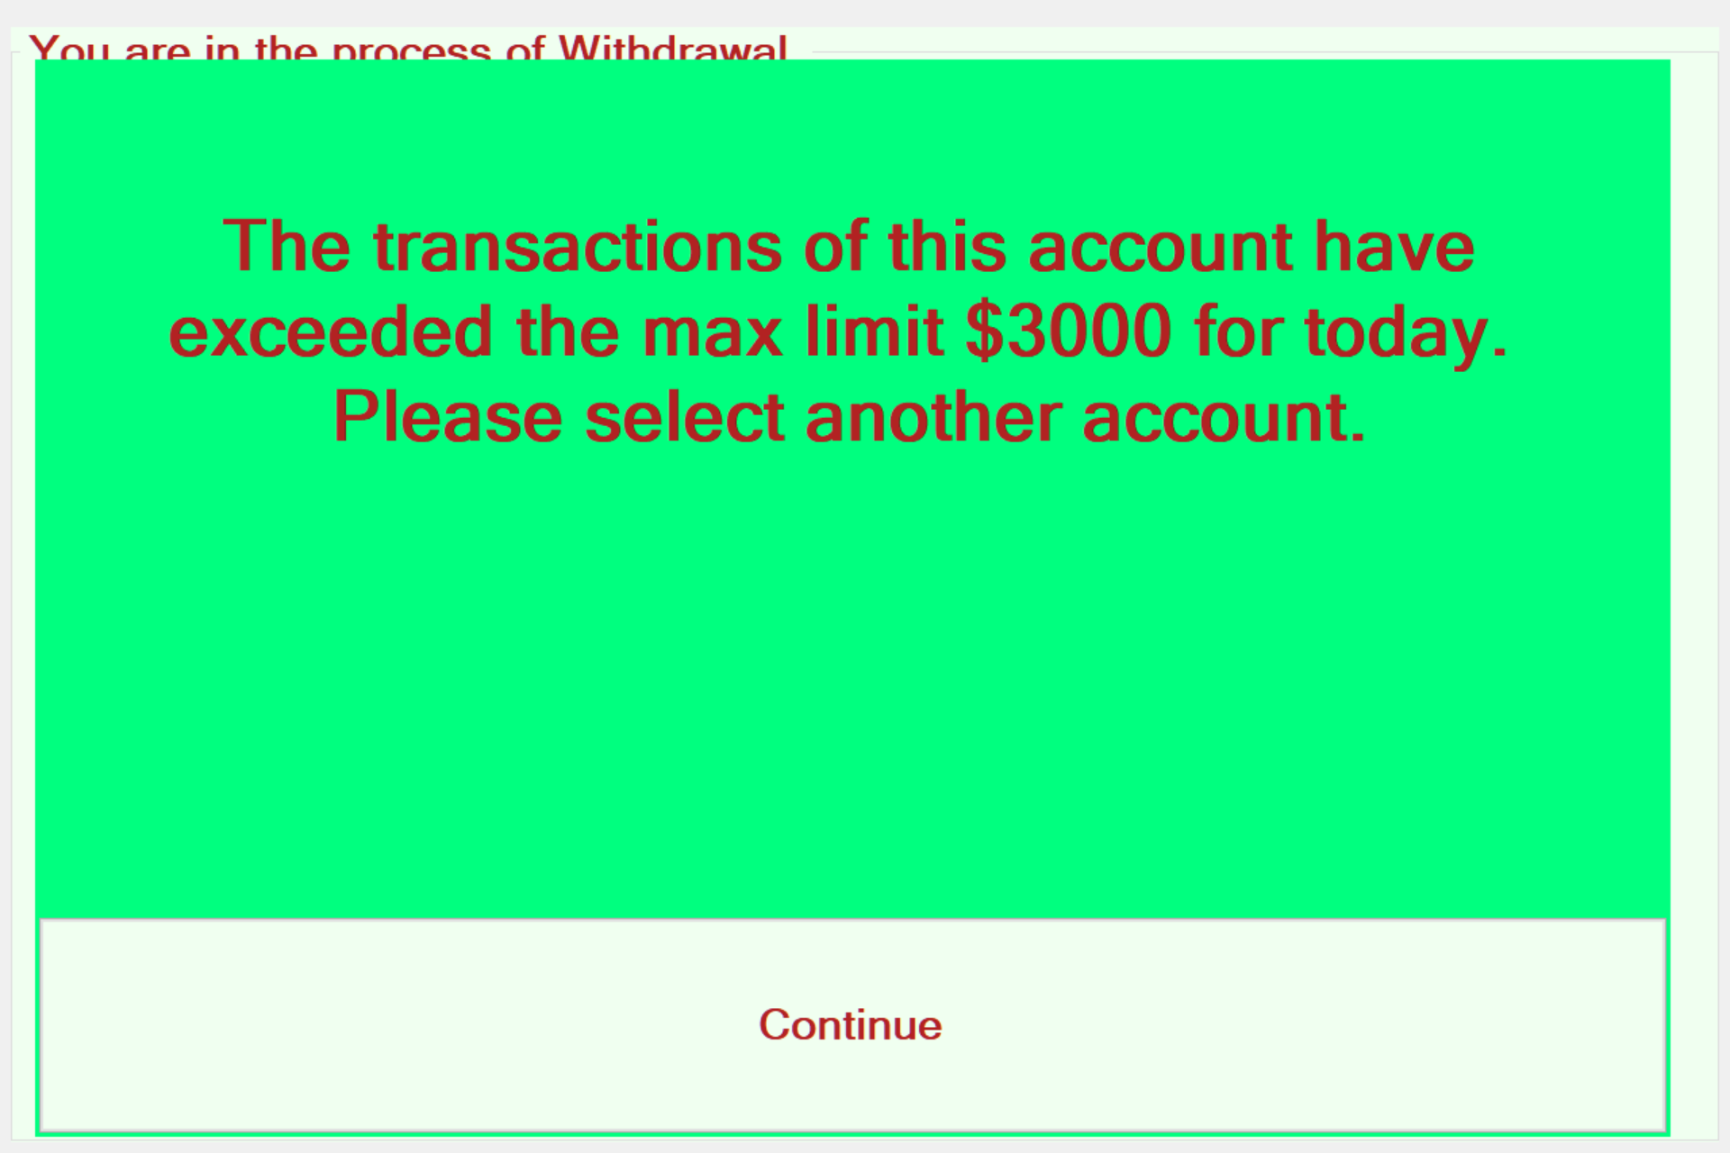

* + 1. If they haven’t reached $3000, the system shall continue Step 1.7.
  1. The system shall request the customer to enter the amount to withdrawal.

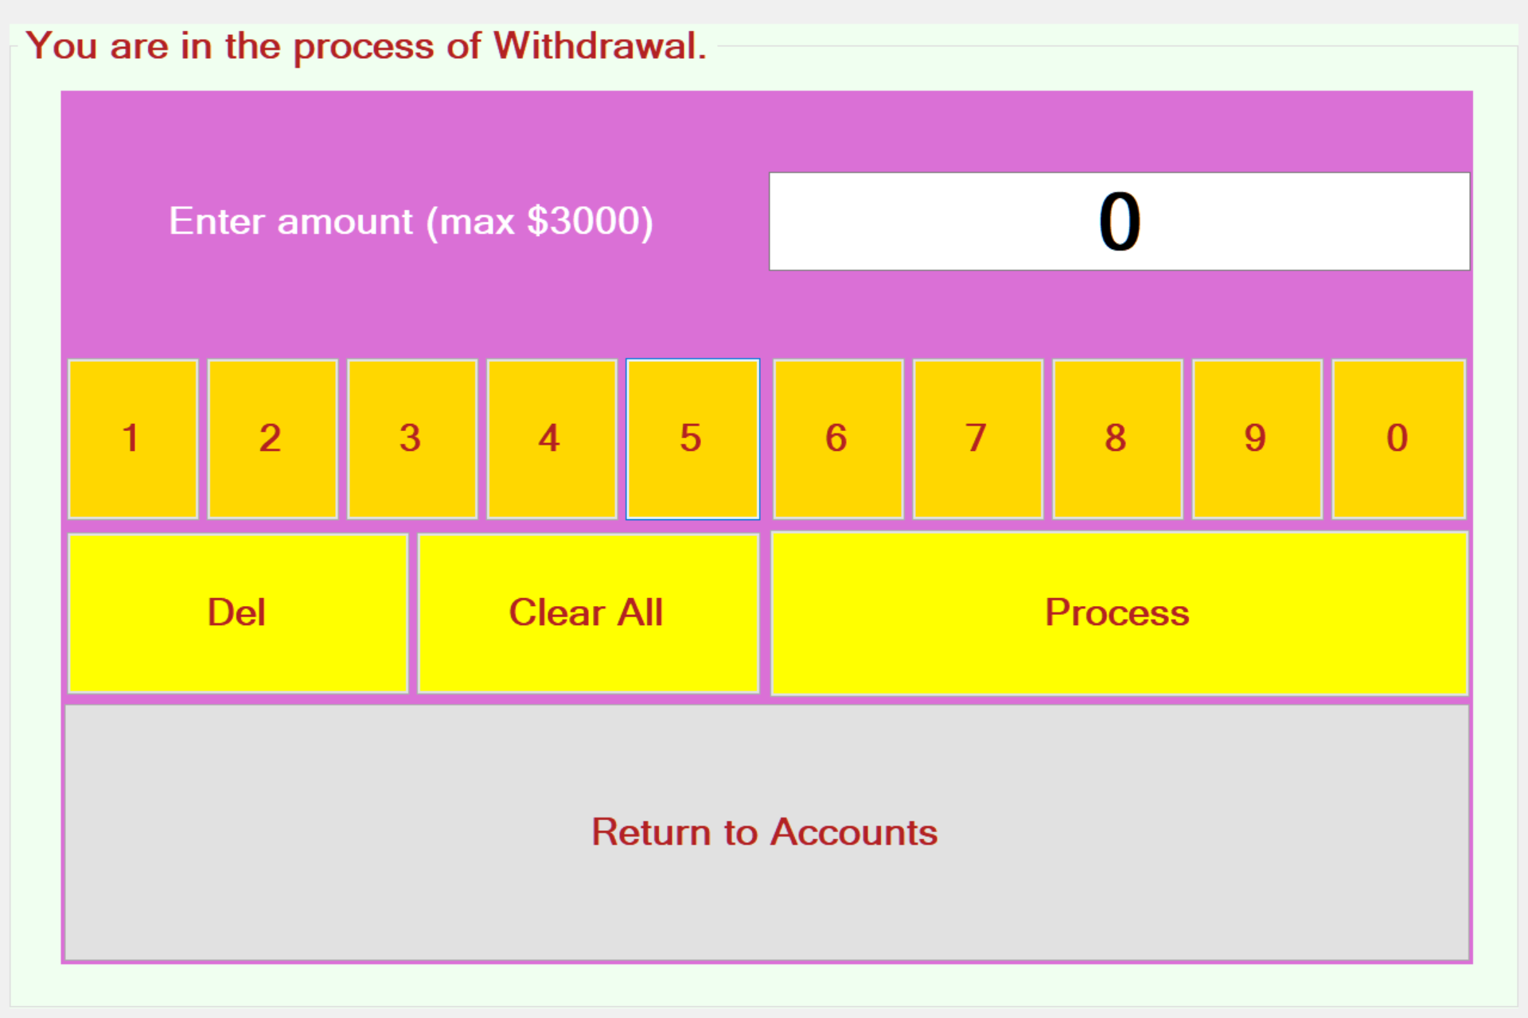

* 1. The customer shall enter an amount.

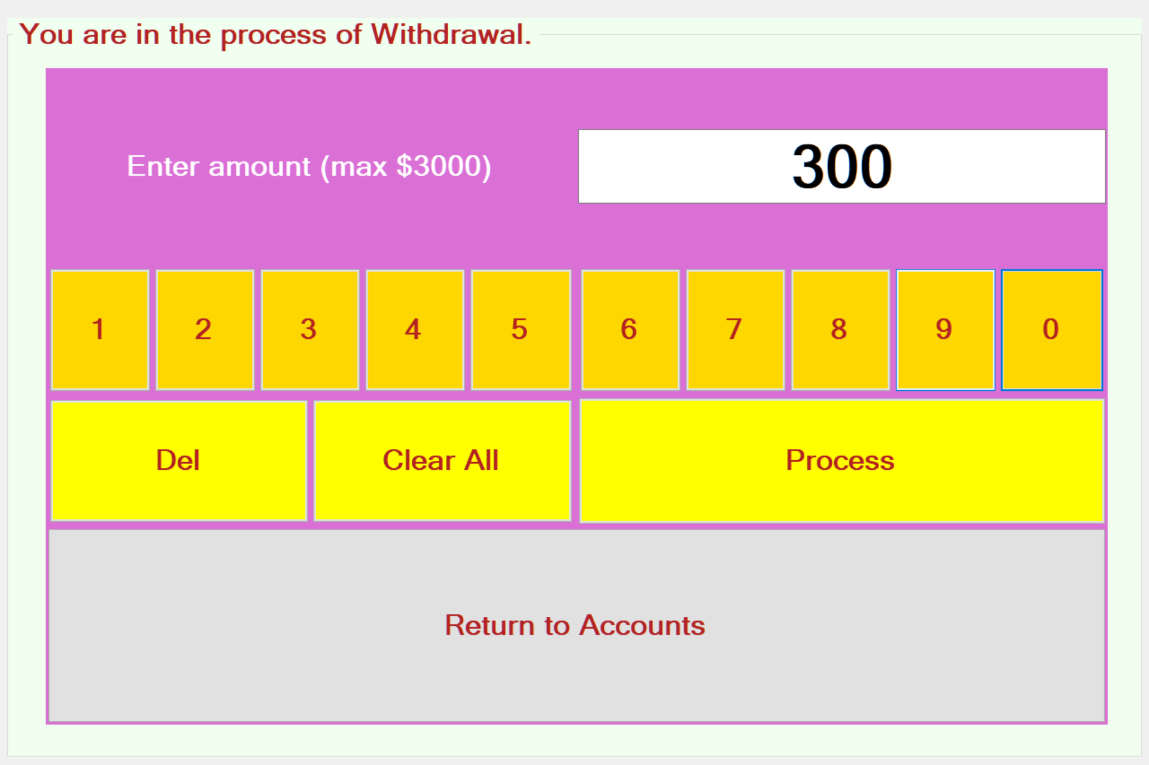

* 1. The system shall check if the total of the amount plus the daily transaction total is greater than $3000 (see NR1).
     1. If the total is greater than $3000, the system shall display an error message to the customer, and return to Step 1.7.

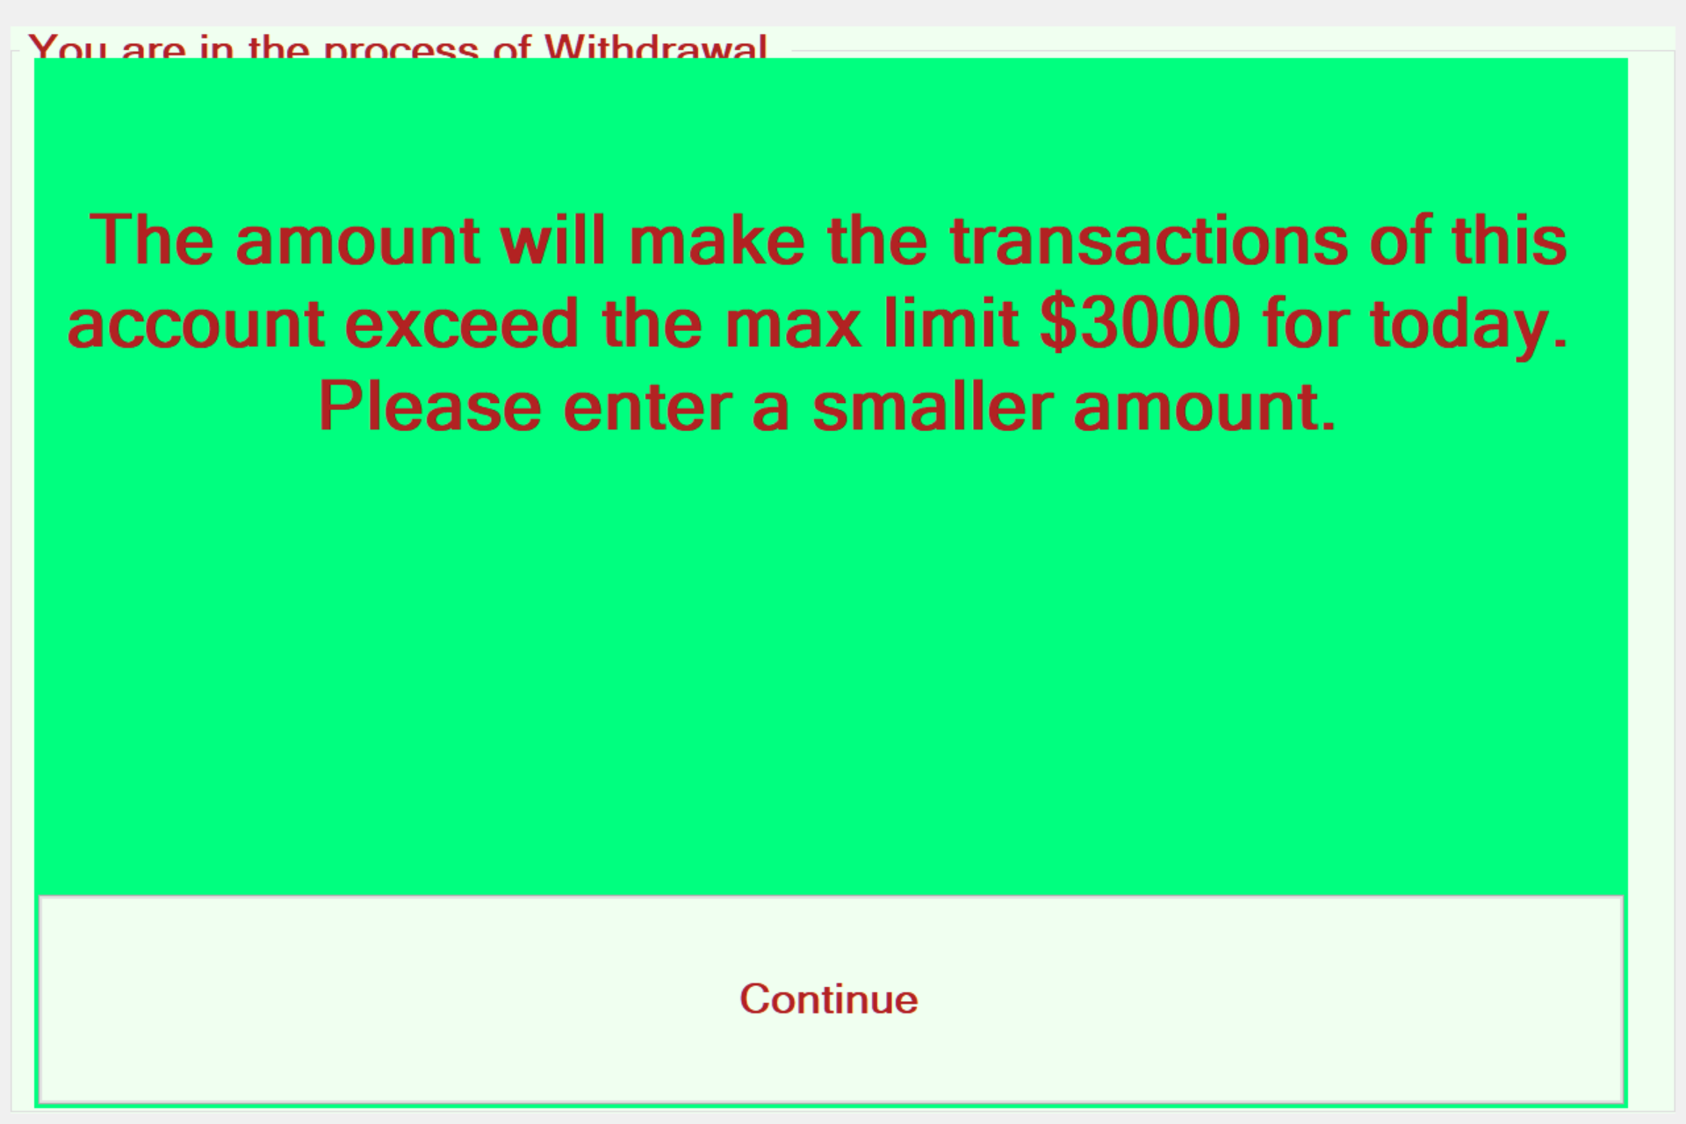

* + 1. If the total is less than or equal to $3000, the system shall continue Step 1.10.
  1. The system shall verify if the amount is less than the current balance of the selected account.
     1. If the amount is greater than the balance, the system shall display an error message to the customer, and return to Step 1.7.

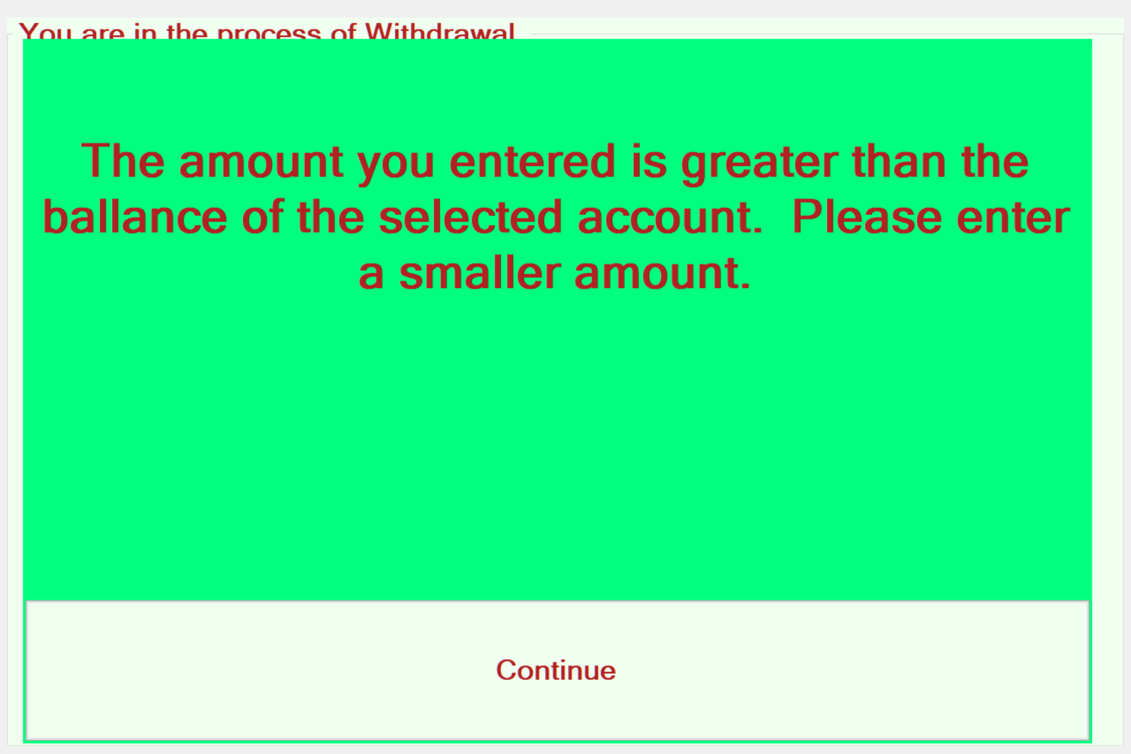

* + 1. If the amount is less than or equal to the current balance, the system shall continue Step 1.11.
  1. The system shall check if the machine has enough cash for the withdrawal.
     1. If there is not enough cash for the withdrawal, the system shall display an error message, and return to Step 1.7.

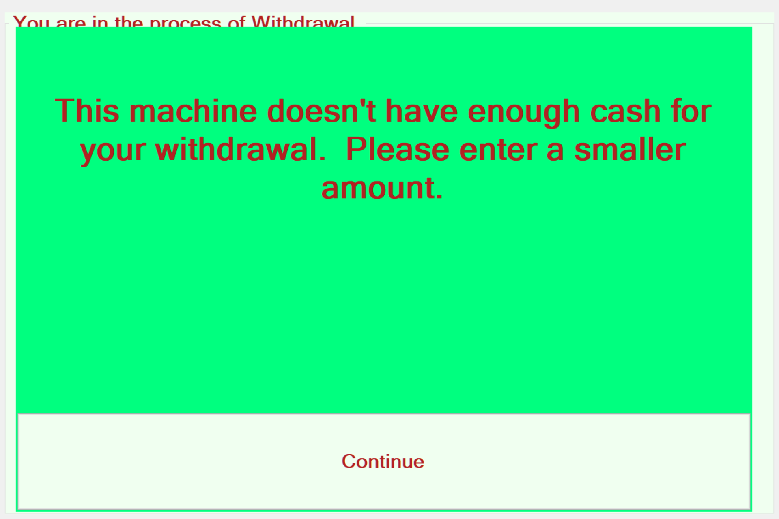

* + 1. If there is enough cash for the withdrawal, the system shall continue Step 1.12.
  1. The system shall dispense the cash.

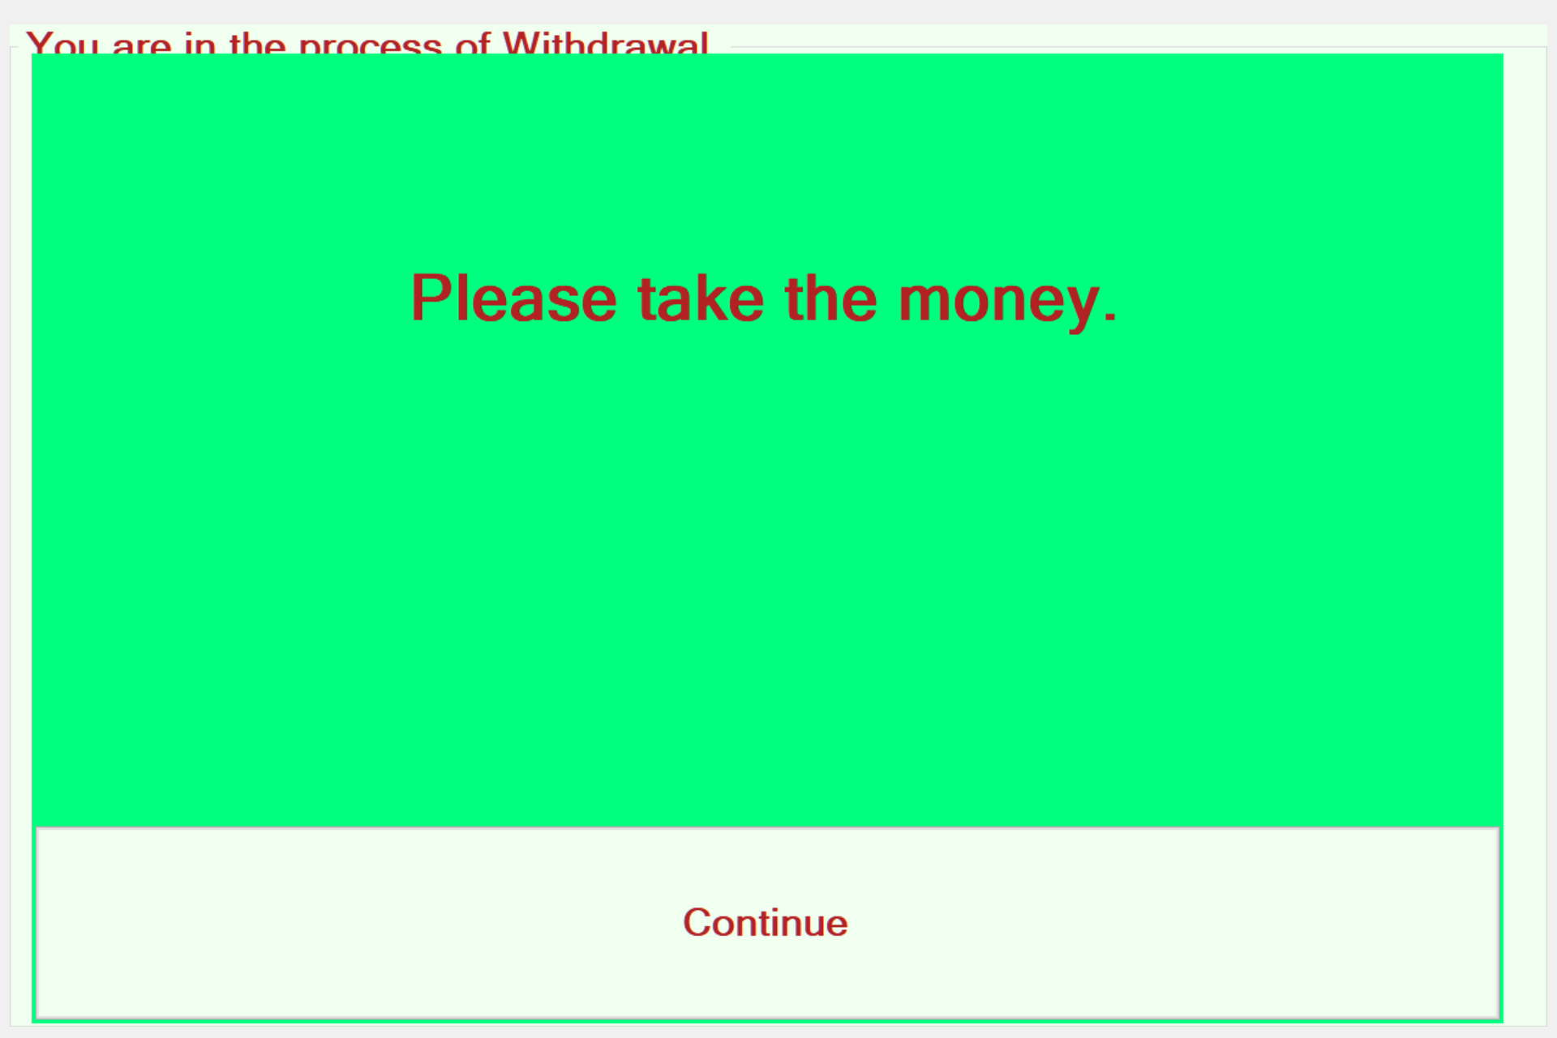

* 1. The system shall deduct the amount from the balance of the account.
  2. The system shall add the amount to the daily transaction total.
  3. The system shall store this transaction to the database.
  4. The system shall update the account information in the database.
  5. The system shall return to main menu.



1. (More?)

Non-functional Requirements:

1. The total of daily transactions (withdrawals ad money transfers) shall not exceed $3000 from same account.
2. The cash in a machine will be reset to $100000 every day. This action will be done manually by the employees of the bank (The software system is not responsible for this part.)
3. The amount of a deposit will not be added to the balance of an account immediately. The system will show the deposit amount in another way. The action for adding the amount to the balance will be done manually by the employees of the bank (The software system is not responsible for this part.)
4. (More?)